**Hope Uganda Newsletter**

**April 2019**

**Thankyou for all of you support!**

Over christmas time, we raised a fantastic amount of money from the christmas stalls and were finally able to start work on the boy’s new toilets. We wanted to get this started before the rainy season hits so that we can then have a new water collection tank up and running.

We have been inundated with new people wanting to help the project in some way, and we received a number of generous donations that have all helped go towards the building of the boy’s toilets.

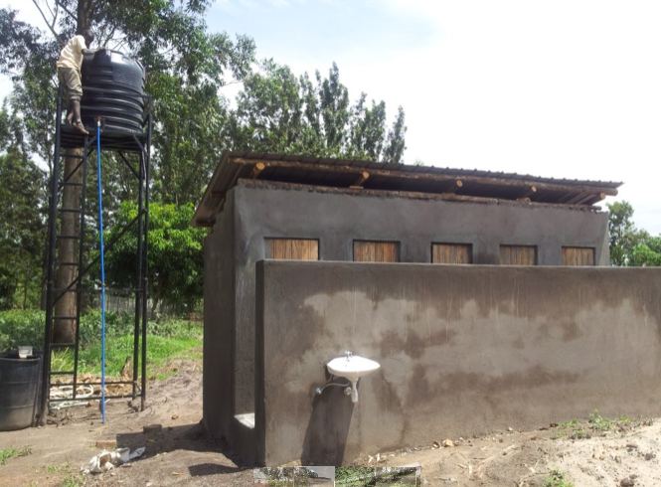

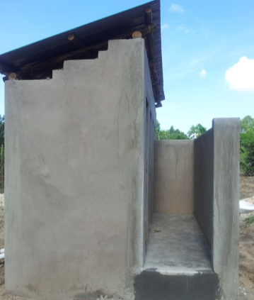

A special shout out to Pure Beauty Valley Beauticians for making us their chosen charity!

A special mention to a certain 40 year old who raised money at her birthday party for the children at HUG!

Thankyou to all of our sponsors!

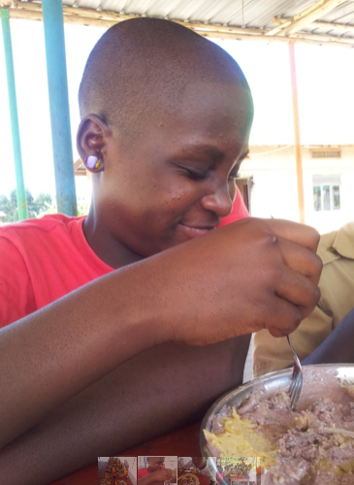 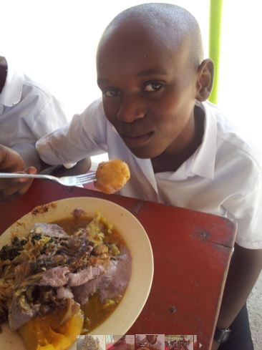 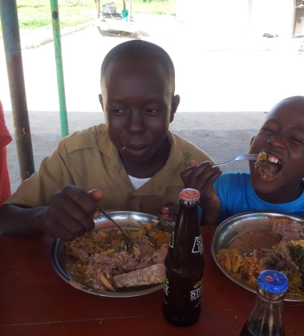

ABOVE: Dorcas, Dickson and Joshua at the RHC Easter meal.

**What are the children up to?**

In January, our eldest three children; Joshua, Dickson and Dorcas moved up to high school. All three are extremely studious, and after spending a lot of time with them last summer, we can sincerely say that their English is amazing and they are making such brilliant progress academically!

In Uganda, it is necessary for children in their final year of primary school to board, so we are happy that we have the children living back with us at Rainbow Hope Centre – and they are now settled into life at high school.

All of our children enjoyed an amazing meal to celebrate Easter. See below!

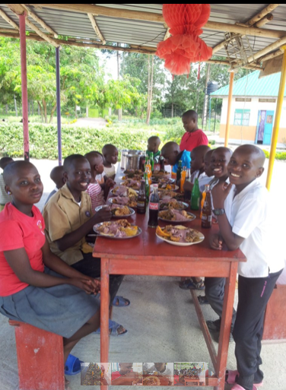 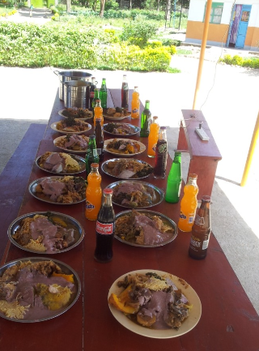

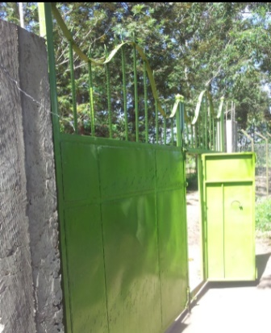

**Volunteer Trip 2019**

Once again. we have a volunteer trip going over to visit our children and do some outreach in September/ October. We are never short of interest in the trips, and pride ourselves on offering a unique ‘Ugandan experience’. Do you fancy being a little spontaneous this year?! We still have a few spaces available!

If this year is too short notice, we are already discussing a trip in the summer of 2020, so if you are interested in getting a bit more information about the trip or just want to know how you can help with donations, please either contact us on our Facebook page, or contact Rachel on 07506549804.

**Keep updated…**

* Our website is always being updated with photos sent from Lydia and Steven so head on over to: [www.hopeuganda.org](http://www.hopeuganda.org) to have a look at everything we have been up to!
* We are also on Facebook, so if you haven’t already, please go and like our page and help us share any news of the upcoming events! This will really help us spread the word!
* Some photo updates are shown below!

Hope Uganda, HUG

**Changes with HUG**

As you may know, HUG has been supported by the same board members for years now. There will be some changes this year within the board and we will be inviting new members to come and join the team, as well as saying goodbye to a member of the team too. We are always looking for new ideas to help keep the momentum of our vision alive and most importantly to ensure the best possible quality of life for our children at RHC. If you have any ideas on fundraising ideas, please let us know! We will introduce you to the new members of our HUG board in the next newsletter, but a warm welcome to Jonny, Laura and Anne! We are already so excited about your fresh ideas and enthusiasm for the charity and for the children!

We are also aiming this year to put our staff at RHC through a variety of training courses such as first aid, risk assessment, occupational health, social work and safety awareness.

Giving the staff these vital skills will help improve their understanding of management and safety in the workplace.

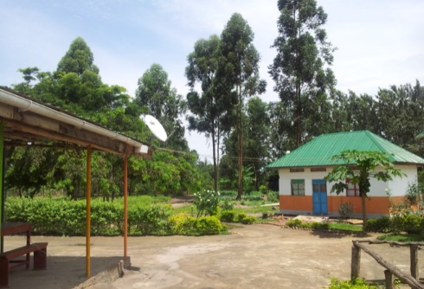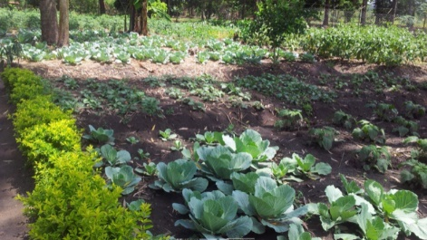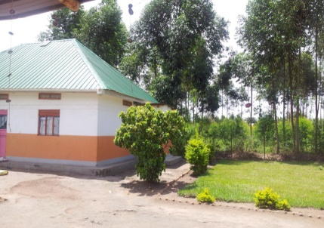

To ensure the children have a future, they need to be educated, and unfortunately, this costs money in Uganda. We are in desperate need of regular donations-every little helps- and our English pound goes such a long way in Ugandan shillings. If you would like to be a part of this brilliant charity and help our children, please contact any member of the charity in person, or text Rachel on: 07506549804

Would you like to sponsor one of our children?